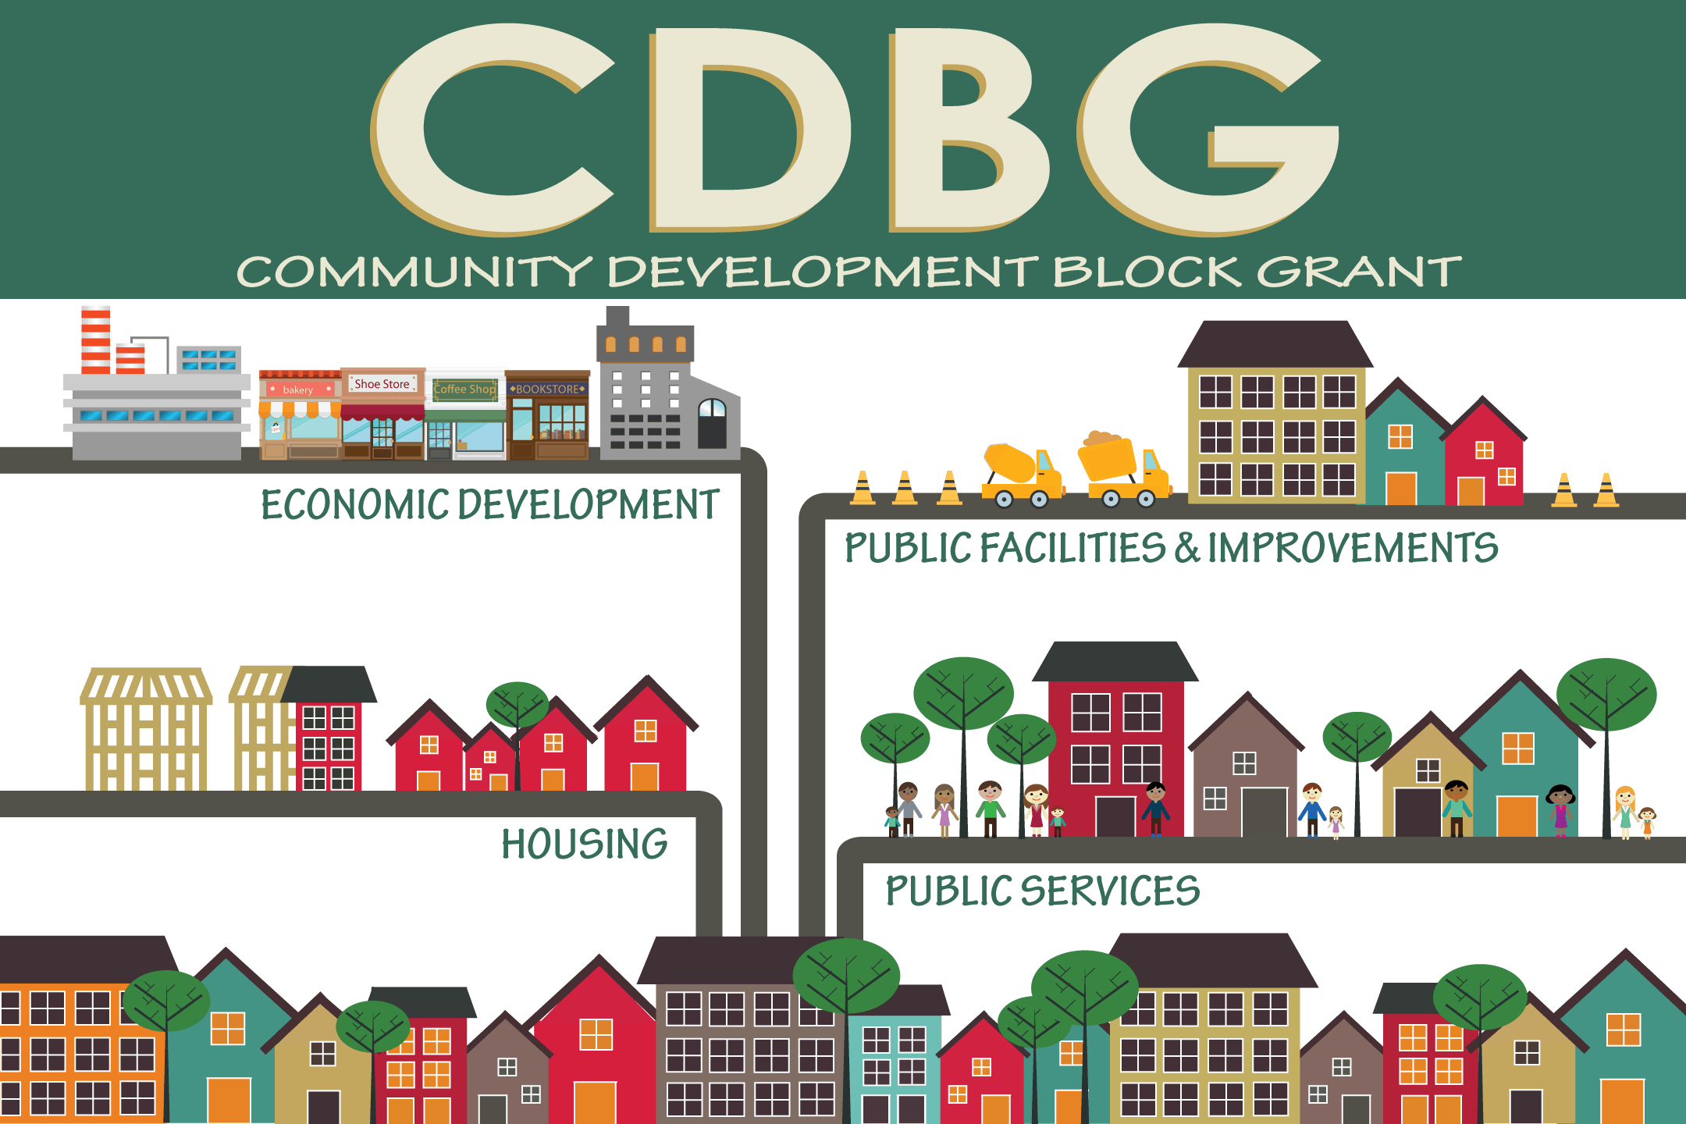
PY2021 CDBG Grant Application Workshop
The City of Marietta will hold an application meeting for the opening of the CDBG Public Services application for program year 2021 (July 1, 2021- June 30, 2022), on Tuesday, December 1st at 10:30 AM. The meeting will be held via WebEx. All attendees must email Kelsey Thompson-White with their name and organization to register and receive a meeting invitation link. Applications will be accepted from December 1, 2020 through January 29th, 2021. Applications should be submitted in-person to the Community Development Office no later than 4:00 P.M. on Friday, January 29th. The application will be available at https://www.mariettaga.gov/472/Forms on December 1st.
ATTENDANCE BY SOMEONE IN THE ORGANIZATION IS REQUIRED TO APPLY FOR FUNDING.
Applicants must be able to verify that they serve City of Marietta residents.
The City of Marietta supports Equal Opportunity and Fair Housing, and does not discriminate in any of its programs on the basis of race, color, creed, ethnicity, sex, familial status, age, religion or disability.
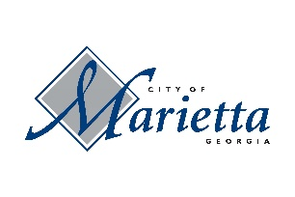

Please direct all comments/inquiries to Kelsey Thompson-White, 268 Lawrence St., Suite 200, Marietta, GA 30060; Telephone: 770-794-5437 or Email: kthompson@mariettaga.gov

